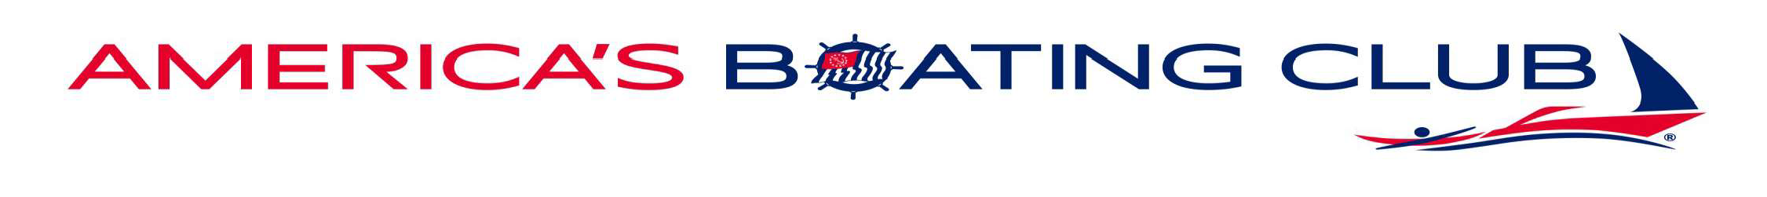
Formerly known as The Saginaw Bay Sail and Power Squadron

***AMERICA'S BOATING COURSE***
Covering the Fundamentals of Safe Boating, Federal and State Laws, Equipment, Finding your way, Charts, Adverse Conditions, Communications, Knots/Lines and more
***Course qualifies the applicant for the Michigan Boater Certification***
Classes will be held on Wednesday nights from 7-9 pm for five weeks and will start on Wednesday, April 23, 2025
Location: Bay Landscaping
1630 SE Boutell Rd., Essexville, MI

Cost: $ 40/student including an excellent manual.
$60/couple sharing manual.

The classroom setting encourages extensive dialog in which the instructor can transfer much of his boating experience to the student.

Upon successful course completion, a certificate will be issued allowing those born on or after 7/1/1996 to operate a boat without restrictions and those 16 years of age and born on or after 12/31/1978 to operate a PWC without restrictions.
Individuals with interest please contact:
Craig Murchison, 989-295-0810, cbmurch2@gmail.com


